|  |
| --- |
| Joshua Gladwin 14 February 2020 |

|  |
| --- |
| IBM Applied Data Science Capstone |
| Moving to Berlin |
| A Neighbourhood Guide for Newcomers to Berlin |

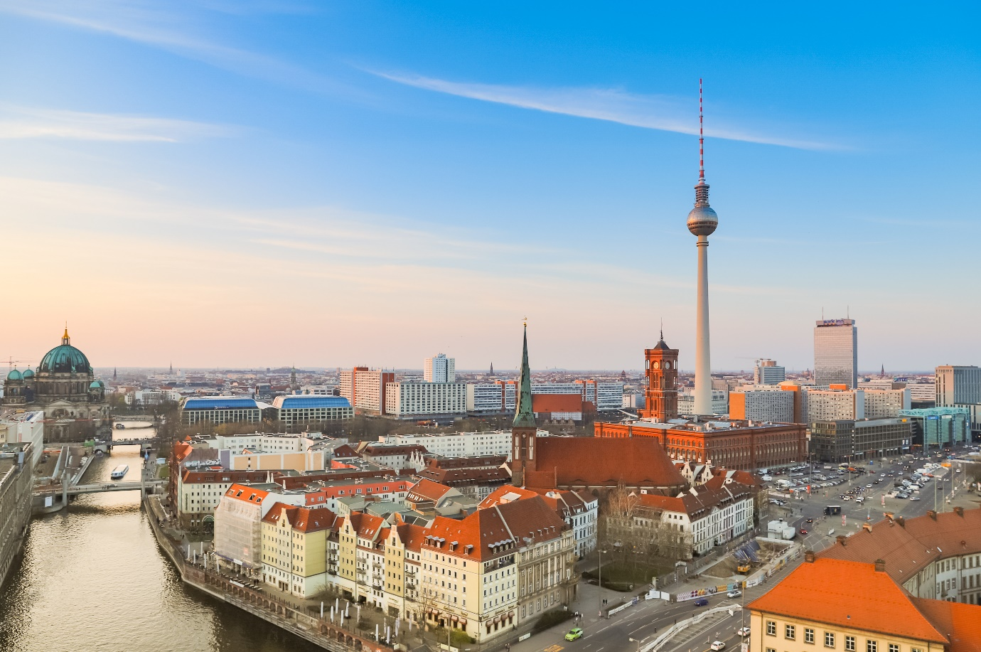

# Introduction

Berlin is one of the fastest growing tech hubs in Europe. With Brexit uncertainty threatening London’s place as the tech capital of Europe, many in the tech industry are looking to relocate to Berlin. The city is noted for its high quality of life and, in comparison to London, low cost of living. Berlin is an international city, with a growing international community. The city is famed for its open and friendly attitude towards women and LGBT people.

## Business Problem/Target Audience

Berlin’s tech companies are often hiring from other cities, such as London and San Francisco, to make sure that they have the best employees with the right skills for their needs. This often requires a relocation process, to aid the new employees move to and settle into Berlin. The aim of this project is to provide newcomers to Berlin with a guide to the various neighbourhoods in Berlin. Many people may have visited Berlin at some point before relocation, but the experience of a tourist is much different to that of someone who lives in Berlin. It is important that a company helps its employees settle into their new city as quickly as possible. If there are problems finding the right neighbourhood to live in, this may have a negative impact on the employee’s performance at work in the crucial early stages of the role. An employee may have to relocate once they have started in the role causing much unnecessary stress. In the worst-case scenario, new recruit may decide to return back to their previous location. It is therefore important that the company does its utmost to ensure that there is a seamless transition from one city to another.

# Data

There are three data sources that are required to solve this task:

* List of the neighbourhoods in Berlin. This forms the backbone of the analysis, providing the main data points to be analysed.
* Latitude and longitude coordinates of the neighbourhoods. This allows the neighbourhoods to be plotted on a map, to better visualise the neighbourhood clusters
* Venue data for each of the neighbourhoods. This provides the information needed to cluster the neighbourhood data.

Firstly, the neighbourhood data is gathered from Wikipedia. Here we can find a list of the 96 *Ortsteile*, the 96 official neighbourhoods within the city-state of Berlin, as designated by the Berlin State government.

Next, using the Geocoder Python package, we can obtain the latitude and longitude of each of the neighbourhoods. With the coordinates of the neighbourhoods, we can now plot the geographic location of each of the neighbourhoods using the mapping library Folium.

Finally, using the Foursquare Venues API, we can get a list of the venues found in each of the neighbourhoods. The venues data can then be used to compare the similarities between each of the neighbourhoods, using K-Means clustering, to group the neighbourhoods into distinct clusters.

# Methodology

To begin with, the list of neighbourhood names is imported into a Jupyter notebook. The CSV file with the neighbourhood consists of a single column, containing only the names of the neighbourhoods. The rest of the data needed for this project still needs to be obtained.

In order to use the Foursquare API later, first we need to acquire the geographic coordinates of each of the neighbourhoods. This can easily be accomplished by using the Geocoder library. Using Geocoder, we can submit the neighbourhoods and Geocoder will return the latitude and longitude coordinates for each of neighbourhood. However, we must be careful that each returns the correct location. To do this, we append “Berlin, DE” to each of the neighbourhoods. This ensures that Geocoder will return the correct location, a location in Berlin, rather than the first example of each neighbourhood name that it finds in its database.

Now that we have the coordinates of each neighbourhood, we can start to retrieve venue information using the Foursquare API. Using the coordinates from Geocoder, we can set this as the centre of each neighbourhood. From this centre, we retrieve up to 75 venues for each neighbourhood, within a radius of 750m. Beyond computational reasons, the limits are placed on the API calls for several reasons. Firstly, not all neighbourhoods are equidistant across the city; some neighbourhoods are closer to each than others. It is important that we set a radius that allows for the greatest range within which we can search for venues in each neighbourhood, without resulting in too much overlap between neighbourhoods. If there is too much overlap, neighbourhoods will end up “sharing” venues and this will cause problems in the clustering later. Secondly, within the stated radius, not every neighbourhood has the same number of venues in it. Only six neighbourhoods in the centre of Berlin have ≥100 venues within 750m. Increasing the limit above 75 venues does little to improve the data quality for the other 90 remaining neighbourhoods, so this seemed like an appropriate point to stop. [See Figure 1]

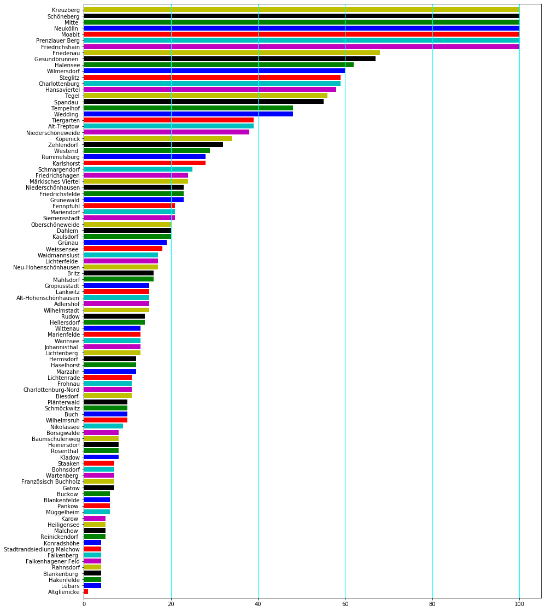

Figure 1: The Number of Venues in each Neighbourhood in descending order

Now that we have our venues, we can start to explore them further. We can see clearly the unique categories of venue in a Wordcloud. The larger the word, the more frequently the venue type appears in our venues. [See Figure 2]

Figure 2: Wordcloud showing the Unique Types of Venue Returned

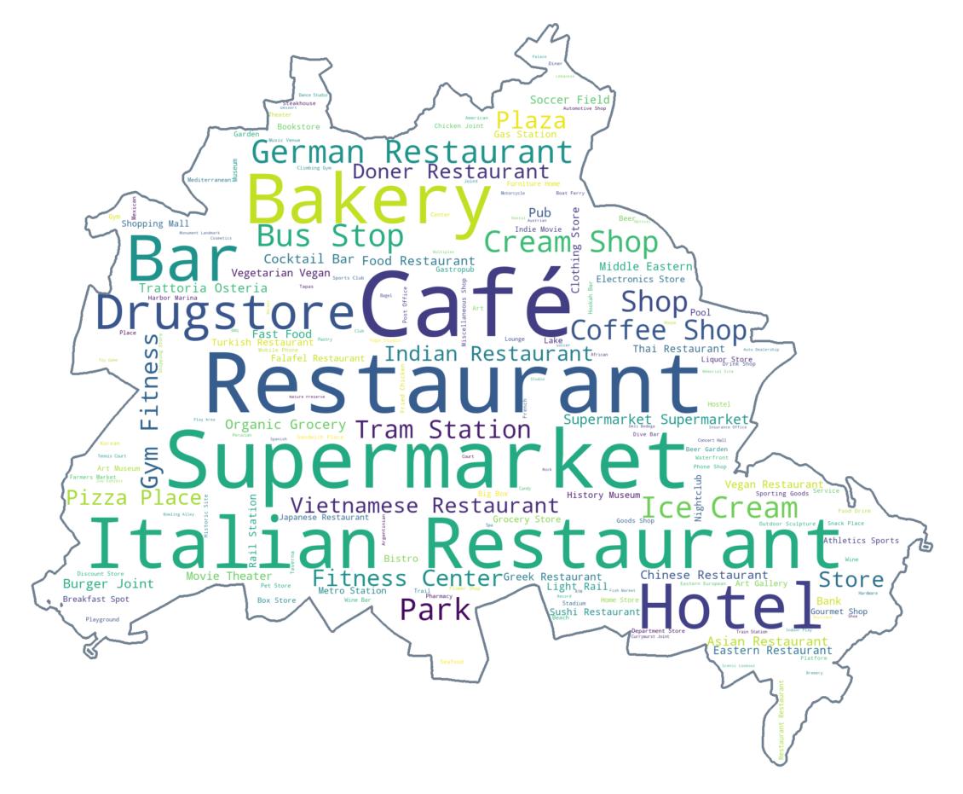

From this we can clearly ascertain that categories such as *Café*, *Restaurant*, *Supermarket*, *Italian Restaurant*, *Bakery* are the most common in Berlin.

Finally, we can begin to cluster the venue data. To do this, we are using a K-Means clustering algorithm to group together the neighbourhoods, based on the similarities of their venues and their frequency in the neighbourhood. The neighbourhoods were sorted into 10 different clusters. To illustrate the clustering, the neighbourhoods were then plotted onto a map, coloured by cluster.

Figure : Map Showing the Berlin Neighbourhoods, Clustered According to Colour

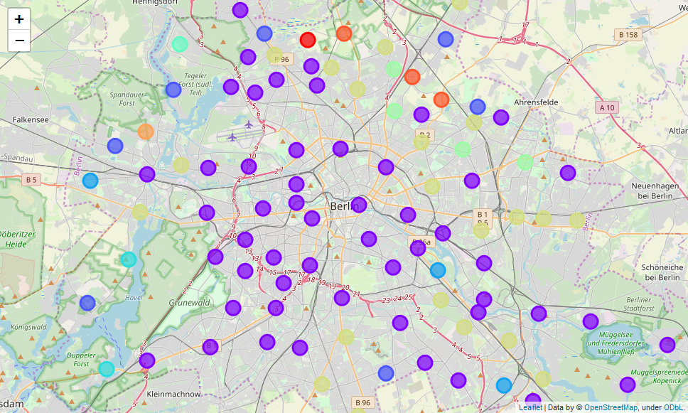

# Results

Below is a summary of the results of the clustering:

[*For full list, see Appendix*]

|  |  |
| --- | --- |
| **Cluster** | **Number of Neighbourhoods** |
| Cluster 1 | 1 |
| Cluster 2 | 52 |
| Cluster 3 | 7 |
| Cluster 4 | 3 |
| Cluster 5 | 3 |
| Cluster 6 | 1 |
| Cluster 7 | 4 |
| Cluster 8 | 21 |
| Cluster 9 | 1 |
| Cluster 10 | 3 |

Overall, the neighbourhoods have been clustered in two different ways – Large clusters (2,8) and the small clusters (3-5, 7, 10) and individual clusters (1,6,9).

The largest cluster, Cluster 2, contains over half of the neighbourhoods. Geographically, they are spread across a large area, mainly western and central Berlin, but also the main transport arteries, such as the motorways and metro lines. The cluster contains a higher concentration of restaurants, cafés and bars when compared to the other clusters.

The next largest cluster, Cluster 8, shows a slightly more sedate picture. These neighbourhoods tend towards the outskirts of the city, towards the north, east and south. There are notably fewer bars and the type of restaurants is unspecified. [i.e. not Chinese or Italian]. Furthermore, the transport links in these neighbourhoods, favouring tram, light rail and train lines over metro lines and motorways.

Figure : Wordcloud of Cluster 2 Figure 5: Wordcloud of Cluster 8

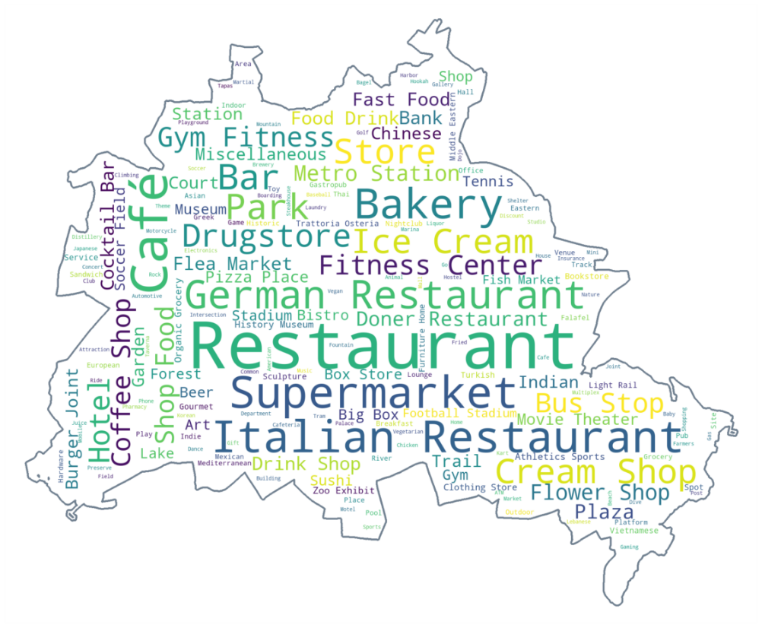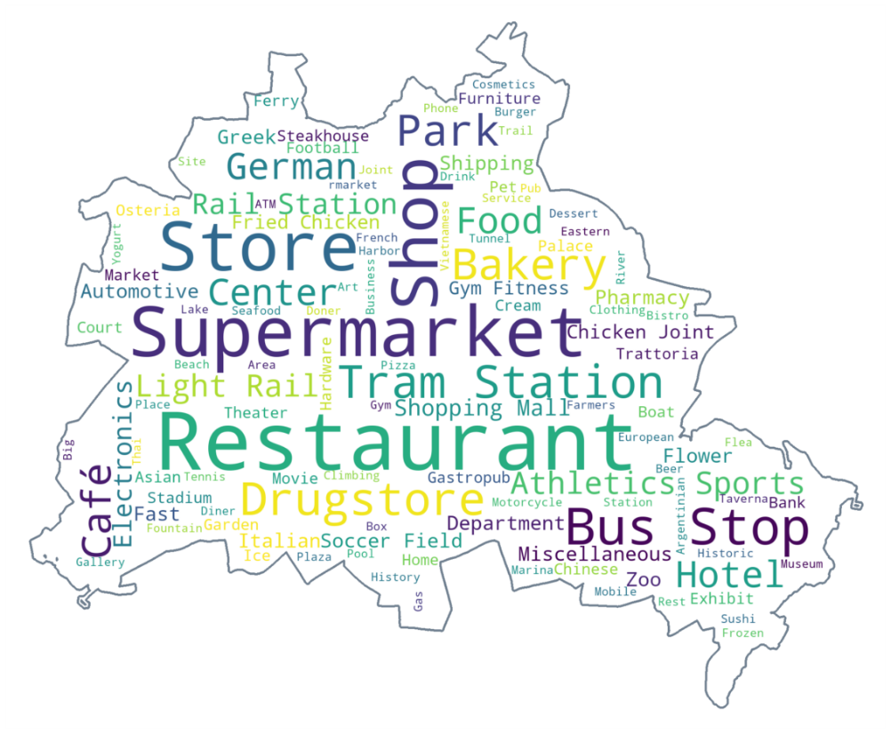

# Discussion

The clustering clearly shows that there are two distinct regions of Berlin – the lively centre and the quieter outskirts. The centre contains much of the Berlin nightlife, with many different types of bars, cafes, restaurants, as well as the more touristy attractions such as the monuments and museums. It also contains the greatest range of venues, with more unique venue categories than the outskirts. [*Figure 4*].

The outskirts, however, may have fewer venues overall, but the proportions are more even, with less dramatic differences between the venues. [*Figure* 5] This suggests that within the cluster, there are fewer differences between the neighbourhoods. However, this also suggests that, compared to the centre, there are fewer “interesting” unique venue categories in the outskirts, meaning a quieter, simpler life. Whether the “variety” of the centre or the “simplicity” of the outskirts is preferable, would be down to the newcomer to Berlin.

However, these two designations only account for two of the ten clusters. The remaining clusters suffer from a great lack of available data from the Foursquare API. Many of the neighbourhoods have less than 20 venues available in the search radius, some less than 10. One neighbourhood, Altglienicke, seems to only contain a single bus stop. Increasing this radius did not necessarily increase the number of venues found in these neighbourhoods, while increasing the processing capacity needed for the more bountiful neighbourhoods. What little data there is, does inform the grouping of some of the clusters. For example, each neighbourhood in cluster 5 contains a *Harbour/Marina* and the most common venue in each neighbourhood in Cluster 7 is a *Tram Station*. With so few venues available, it’s difficult to be able to categorise the neighbourhoods in any way useful to the original problem. How can we ascertain what sort of location Altglienicke is when all we have to go on is a bus stop?

With the lack of venues to act as data points, many of these smaller clusters are bound together not by what they have in common, but what they *lack* in common. Some of the “most common” venue categories in these neighbourhood clusters, for example Cluster 3, include *Zoo Exhibit*, *Flea Market*, *Flower Shop*, *Food & Drink Shop*, *Food Court*, *Football Stadium*. [*See Appendix*] However, the frequency of these venues in these neighbourhoods is 0, making up 0% of the venues in the neighbourhood. But to the K-Means clustering algorithm, seeing this lack of venues as informative as the presence of a venue, and with very little other data available, these neighbourhoods are clustered together.

# Conclusion

In this project, we have examined the neighbourhoods of Berlin. We have identified the geographic coordinates of each neighbourhood and then, using the Foursquare API, retrieved a list of venues for each neighbourhood. Then, using a K-Means clustering algorithm, we clustered the neighbourhoods. This produced a broad separation of Berlin into two main areas, the Western/Centre of Berlin and the Eastern/Outskirts.

In future, it would be interesting to see what results we could find with a more complete dataset of venue data, especially for outside of the inner city. Further, while the Foursquare API gives us specific venue categories, it would be better to find a way to show the interconnected relationship between these venue types. *Restaurant*, *Japanese Restaurant*, and *Sushi Restaurant*, for example, all appear as venue categories. However, at present, a *Sushi Restaurant* has no relationship in the data as a type of the *Restaurant* category, though clearly one is a subset of a larger set. Finding some way to show the venue types as sets would allow for a better clustering of the neighbourhoods.

# Bibliography

## NomadList, 2019. *Cost of Living in Berlin.* [Online] Available at: https://nomadlist.com/berlin [Accessed 22 01 2020].

## Wikipedia, 2019. *Boroughs and neighborhoods of Berlin - Wikipedia.* [Online] Available at: https://en.wikipedia.org/wiki/Boroughs_and_neighborhoods_of_Berlin [Accessed 22 01 2020].

# Appendix

## Cluster 1

|  | **Neighbourhood** | **1st Most Common Venue** | **2nd Most Common Venue** | **3rd Most Common Venue** | **4th Most Common Venue** | **5th Most Common Venue** | **6th Most Common Venue** | **7th Most Common Venue** | **8th Most Common Venue** | **9th Most Common Venue** | **10th Most Common Venue** |
| --- | --- | --- | --- | --- | --- | --- | --- | --- | --- | --- | --- |
| **50** | Lübars | Restaurant | Stables | Comfort Food Restaurant | Ice Cream Shop | Zoo Exhibit | Football Stadium | Fish Market | Flea Market | Flower Shop | Food & Drink Shop |

## Cluster 2

|  | **Neighbourhood** | **1st Most Common Venue** | **2nd Most Common Venue** | **3rd Most Common Venue** | **4th Most Common Venue** | **5th Most Common Venue** | **6th Most Common Venue** | **7th Most Common Venue** | **8th Most Common Venue** | **9th Most Common Venue** | **10th Most Common Venue** |
| --- | --- | --- | --- | --- | --- | --- | --- | --- | --- | --- | --- |
| **2** | Alt-Treptow | Nightclub | Café | Bakery | ATM | Tapas Restaurant | Bar | Park | Beer Garden | Big Box Store | Outdoor Sculpture |
| **8** | Bohnsdorf | Home Service | Italian Restaurant | Insurance Office | Soccer Field | Doner Restaurant | Park | Football Stadium | Fish Market | Flea Market | Flower Shop |
| **9** | Borsigwalde | Motorcycle Shop | Fast Food Restaurant | Athletics & Sports | Toy / Game Store | Go Kart Track | Flower Shop | Food & Drink Shop | Food Court | Football Stadium | Forest |
| **10** | Britz | Metro Station | Eastern European Restaurant | German Restaurant | Mini Golf | Historic Site | History Museum | Bakery | Park | Palace | Lake |
| **13** | Charlottenburg | Supermarket | Café | Chinese Restaurant | Taverna | Italian Restaurant | Drugstore | Asian Restaurant | Gourmet Shop | Bank | Bakery |
| **14** | Charlottenburg-Nord | Building | Rock Climbing Spot | Metro Station | Mexican Restaurant | Beer Garden | Miscellaneous Shop | Soccer Field | Park | Plaza | Supermarket |
| **15** | Dahlem | German Restaurant | Museum | Café | Burger Joint | Chinese Restaurant | Fast Food Restaurant | Bookstore | Coffee Shop | Indie Movie Theater | Gym |
| **16** | Falkenberg | Animal Shelter | Coffee Shop | Mountain | Park | Zoo Exhibit | Fountain | Flower Shop | Food & Drink Shop | Food Court | Football Stadium |
| **20** | Friedenau | Café | Supermarket | Italian Restaurant | Vietnamese Restaurant | Bakery | Organic Grocery | Korean Restaurant | Hookah Bar | Greek Restaurant | Bistro |
| **22** | Friedrichshagen | Organic Grocery | Café | Ice Cream Shop | Beach | Japanese Restaurant | Trattoria/Osteria | Plaza | Drugstore | Park | Brewery |
| **23** | Friedrichshain | Café | Coffee Shop | Vegetarian / Vegan Restaurant | Bar | Nightclub | Cocktail Bar | Pizza Place | Middle Eastern Restaurant | Bagel Shop | Thai Restaurant |
| **24** | Frohnau | Supermarket | Italian Restaurant | Bar | Bakery | Miscellaneous Shop | Coffee Shop | Pizza Place | Ice Cream Shop | Café | Doner Restaurant |
| **26** | Gesundbrunnen | Café | Bar | Drugstore | Turkish Restaurant | Ice Cream Shop | Bookstore | Trail | Platform | Hotel | Italian Restaurant |
| **27** | Gropiusstadt | Metro Station | Supermarket | Trail | Football Stadium | Farmers Market | Gym / Fitness Center | Gym | Grocery Store | Tennis Stadium | Café |
| **29** | Grunewald | German Restaurant | Italian Restaurant | Lake | Café | Supermarket | Bus Stop | Platform | Tennis Stadium | Historic Site | Trail |
| **31** | Halensee | Plaza | Hotel | Supermarket | Italian Restaurant | Café | Gym / Fitness Center | Indian Restaurant | Bakery | Drugstore | German Restaurant |
| **32** | Hansaviertel | Bakery | Café | Restaurant | Hotel | Outdoor Sculpture | Park | Light Rail Station | Gastropub | Gym / Fitness Center | Bistro |
| **36** | Hellersdorf | Metro Station | Gym / Fitness Center | Supermarket | Ice Cream Shop | Multiplex | German Restaurant | Big Box Store | Bus Stop | Bank | Bakery |
| **39** | Karlshorst | Supermarket | Bakery | Playground | Organic Grocery | Light Rail Station | Greek Restaurant | German Restaurant | Sushi Restaurant | Café | Italian Restaurant |
| **44** | Köpenick | Soccer Stadium | Clothing Store | Café | Bakery | Drugstore | Gym / Fitness Center | River | German Restaurant | Bar | Trail |
| **45** | Kreuzberg | Bar | Coffee Shop | Café | Turkish Restaurant | Bakery | Cocktail Bar | German Restaurant | Dance Studio | Lounge | Indie Movie Theater |
| **46** | Lankwitz | Bakery | Drugstore | Italian Restaurant | Ice Cream Shop | Supermarket | Movie Theater | German Restaurant | Soccer Field | Park | Fast Food Restaurant |
| **47** | Lichtenberg | Furniture / Home Store | Tram Station | Hotel | Miscellaneous Shop | Bakery | Pool Hall | Indoor Play Area | Cafeteria | Café | Hardware Store |
| **49** | Lichterfelde | Bus Stop | Bakery | Italian Restaurant | Track Stadium | Chinese Restaurant | Pool | Supermarket | Plaza | Bank | Eastern European Restaurant |
| **55** | Märkisches Viertel | Italian Restaurant | Hotel | Athletics & Sports | Fast Food Restaurant | Miscellaneous Shop | Baseball Field | Bank | Gift Shop | Electronics Store | Gym / Fitness Center |
| **57** | Mitte | Hotel | Café | History Museum | Museum | Art Museum | Ice Cream Shop | Art Gallery | Restaurant | Plaza | German Restaurant |
| **58** | Moabit | Gym / Fitness Center | German Restaurant | Burger Joint | Cocktail Bar | Supermarket | Bar | Café | Doner Restaurant | Italian Restaurant | Hotel |
| **59** | Müggelheim | Gym | American Restaurant | Supermarket | Harbor / Marina | German Restaurant | IT Services | Café | Zoo Exhibit | Flower Shop | Food & Drink Shop |
| **61** | Neukölln | Bar | Coffee Shop | Café | Cocktail Bar | Italian Restaurant | Turkish Restaurant | Bistro | Dive Bar | Middle Eastern Restaurant | Lebanese Restaurant |
| **62** | Niederschöneweide | Supermarket | Café | Bakery | History Museum | Indian Restaurant | Falafel Restaurant | Juice Bar | Furniture / Home Store | Motel | Movie Theater |
| **64** | Nikolassee | Trail | Park | Intersection | Supermarket | Coffee Shop | Lake | Asian Restaurant | Light Rail Station | Fish Market | Flea Market |
| **65** | Oberschöneweide | Supermarket | Burger Joint | Café | Movie Theater | Pizza Place | Gym / Fitness Center | History Museum | Forest | Bakery | Laundry Service |
| **68** | Prenzlauer Berg | Café | Vietnamese Restaurant | Bakery | Gourmet Shop | Coffee Shop | Italian Restaurant | Beer Bar | Bar | Cocktail Bar | Falafel Restaurant |
| **69** | Rahnsdorf | Indian Restaurant | River | German Restaurant | Ice Cream Shop | Athletics & Sports | Zoo Exhibit | Fish Market | Flea Market | Flower Shop | Food & Drink Shop |
| **70** | Reinickendorf | Gastropub | Nature Preserve | Hostel | Liquor Store | Ice Cream Shop | Forest | Flea Market | Flower Shop | Food & Drink Shop | Food Court |
| **72** | Rudow | Ice Cream Shop | Italian Restaurant | Doner Restaurant | Miscellaneous Shop | Bank | Drugstore | Metro Station | Supermarket | Department Store | Bus Stop |
| **73** | Rummelsburg | Café | German Restaurant | Lake | Restaurant | Soccer Field | Bus Stop | Boarding House | Supermarket | Beer Garden | Theme Park Ride / Attraction |
| **74** | Schmargendorf | Gym | Italian Restaurant | Ice Cream Shop | Sports Club | Café | Chinese Restaurant | Tennis Court | Bookstore | Bus Stop | Restaurant |
| **76** | Schöneberg | Italian Restaurant | Café | Bistro | Grocery Store | Supermarket | Restaurant | Pizza Place | Coffee Shop | Ice Cream Shop | German Restaurant |
| **77** | Siemensstadt | Metro Station | Furniture / Home Store | Supermarket | Pizza Place | Fast Food Restaurant | Hardware Store | Sandwich Place | German Restaurant | Baby Store | Hotel |
| **78** | Spandau | Clothing Store | Ice Cream Shop | Drugstore | Bakery | Fast Food Restaurant | Restaurant | Pub | Sushi Restaurant | Mobile Phone Shop | Italian Restaurant |
| **80** | Stadtrandsiedlung Malchow | Restaurant | Indoor Play Area | Automotive Shop | Athletics & Sports | Zoo Exhibit | Forest | Fish Market | Flea Market | Flower Shop | Food & Drink Shop |
| **81** | Steglitz | Sushi Restaurant | Gym / Fitness Center | Trattoria/Osteria | Martial Arts Dojo | Clothing Store | Toy / Game Store | Bus Stop | Café | Pub | Italian Restaurant |
| **82** | Tegel | Café | Clothing Store | Restaurant | Drugstore | Mediterranean Restaurant | Sandwich Place | Thai Restaurant | Italian Restaurant | Shopping Mall | Indian Restaurant |
| **83** | Tempelhof | Supermarket | Café | Doner Restaurant | Italian Restaurant | Park | Fried Chicken Joint | Drugstore | Bakery | Indian Restaurant | Breakfast Spot |
| **84** | Tiergarten | Hotel | Art Museum | Plaza | Breakfast Spot | German Restaurant | Hotel Bar | Lounge | Park | Sculpture Garden | Cocktail Bar |
| **88** | Wedding | Café | Bar | Burger Joint | Chinese Restaurant | Middle Eastern Restaurant | Supermarket | Big Box Store | Park | Ice Cream Shop | Tennis Court |
| **90** | Westend | Café | Gas Station | Park | Metro Station | Italian Restaurant | Plaza | Bakery | Ice Cream Shop | Bus Stop | Flower Shop |
| **91** | Wilhelmsruh | Music Venue | Discount Store | Bus Stop | Mexican Restaurant | Pharmacy | Restaurant | Distillery | Flea Market | Garden | Gaming Cafe |
| **93** | Wilmersdorf | Bakery | German Restaurant | Doner Restaurant | Café | Burger Joint | Bus Stop | Organic Grocery | Supermarket | Drugstore | Vietnamese Restaurant |
| **94** | Wittenau | Park | Italian Restaurant | Supermarket | German Restaurant | Concert Hall | Mediterranean Restaurant | Post Office | Restaurant | Metro Station | Trattoria/Osteria |
| **95** | Zehlendorf | Café | Italian Restaurant | Doner Restaurant | Drugstore | Bank | Steakhouse | Gym / Fitness Center | Big Box Store | Gourmet Shop | Sushi Restaurant |

## Cluster 3

|  | **Neighbourhood** | **1st Most Common Venue** | **2nd Most Common Venue** | **3rd Most Common Venue** | **4th Most Common Venue** | **5th Most Common Venue** | **6th Most Common Venue** | **7th Most Common Venue** | **8th Most Common Venue** | **9th Most Common Venue** | **10th Most Common Venue** |
| --- | --- | --- | --- | --- | --- | --- | --- | --- | --- | --- | --- |
| **12** | Buckow | Supermarket | Indian Restaurant | Discount Store | German Restaurant | Fast Food Restaurant | Flea Market | Flower Shop | Food & Drink Shop | Food Court | Football Stadium |
| **17** | Falkenhagener Feld | Drugstore | Supermarket | Snack Place | Soccer Field | Zoo Exhibit | Flea Market | Flower Shop | Food & Drink Shop | Food Court | Football Stadium |
| **37** | Hermsdorf | Supermarket | Italian Restaurant | Bakery | Drugstore | Organic Grocery | Sushi Restaurant | Lake | Wine Shop | Seafood Restaurant | Frozen Yogurt Shop |
| **40** | Karow | Supermarket | Mattress Store | Italian Restaurant | German Restaurant | Zoo Exhibit | Forest | Flea Market | Flower Shop | Food & Drink Shop | Food Court |
| **42** | Kladow | Supermarket | Pharmacy | Organic Grocery | Bus Stop | Liquor Store | Pier | Food Court | Fish Market | Flea Market | Flower Shop |
| **43** | Konradshöhe | Supermarket | Diner | Bus Stop | Fountain | Flea Market | Flower Shop | Food & Drink Shop | Food Court | Football Stadium | Forest |
| **87** | Wartenberg | Supermarket | Discount Store | Soccer Field | Business Service | Gym / Fitness Center | Zoo Exhibit | Forest | Flower Shop | Food & Drink Shop | Food Court |

## Cluster 4

|  | **Neighbourhood** | **1st Most Common Venue** | **2nd Most Common Venue** | **3rd Most Common Venue** | **4th Most Common Venue** | **5th Most Common Venue** | **6th Most Common Venue** | **7th Most Common Venue** | **8th Most Common Venue** | **9th Most Common Venue** | **10th Most Common Venue** |
| --- | --- | --- | --- | --- | --- | --- | --- | --- | --- | --- | --- |
| **3** | Altglienicke | Bus Stop | Zoo Exhibit | Fountain | Flea Market | Flower Shop | Food & Drink Shop | Food Court | Football Stadium | Forest | French Restaurant |
| **67** | Plänterwald | Bus Stop | Playground | Supermarket | Liquor Store | Lake | Light Rail Station | Zoo Exhibit | Football Stadium | Flea Market | Flower Shop |
| **79** | Staaken | Bus Stop | Restaurant | Italian Restaurant | Zoo Exhibit | Forest | Fish Market | Flea Market | Flower Shop | Food & Drink Shop | Food Court |

## Cluster 5

|  | **Neighbourhood** | **1st Most Common Venue** | **2nd Most Common Venue** | **3rd Most Common Venue** | **4th Most Common Venue** | **5th Most Common Venue** | **6th Most Common Venue** | **7th Most Common Venue** | **8th Most Common Venue** | **9th Most Common Venue** | **10th Most Common Venue** |
| --- | --- | --- | --- | --- | --- | --- | --- | --- | --- | --- | --- |
| **25** | Gatow | Farmers Market | Italian Restaurant | Supermarket | Harbor / Marina | Bus Stop | Trattoria/Osteria | Hotel | Food Court | Fish Market | Flea Market |
| **75** | Schmöckwitz | Harbor / Marina | Supermarket | Miscellaneous Shop | Tram Station | Hotel | German Restaurant | Ice Cream Shop | Gas Station | Italian Restaurant | French Restaurant |
| **86** | Wannsee | Harbor / Marina | Supermarket | Austrian Restaurant | Post Office | Chinese Restaurant | Bank | Bakery | Lake | Indian Restaurant | Liquor Store |

## Cluster 6

|  | **Neighbourhood** | **1st Most Common Venue** | **2nd Most Common Venue** | **3rd Most Common Venue** | **4th Most Common Venue** | **5th Most Common Venue** | **6th Most Common Venue** | **7th Most Common Venue** | **8th Most Common Venue** | **9th Most Common Venue** | **10th Most Common Venue** |
| --- | --- | --- | --- | --- | --- | --- | --- | --- | --- | --- | --- |
| **34** | Heiligensee | Insurance Office | Photography Studio | Forest | Fast Food Restaurant | Fish Market | Flea Market | Flower Shop | Food & Drink Shop | Food Court | Football Stadium |

## Cluster 7

|  | **Neighbourhood** | **1st Most Common Venue** | **2nd Most Common Venue** | **3rd Most Common Venue** | **4th Most Common Venue** | **5th Most Common Venue** | **6th Most Common Venue** | **7th Most Common Venue** | **8th Most Common Venue** | **9th Most Common Venue** | **10th Most Common Venue** |
| --- | --- | --- | --- | --- | --- | --- | --- | --- | --- | --- | --- |
| **1** | Alt-Hohenschönhausen | Tram Station | Discount Store | Ice Cream Shop | Soccer Field | Post Office | Supermarket | Greek Restaurant | Drugstore | Asian Restaurant | Indian Restaurant |
| **35** | Heinersdorf | Tram Station | Discount Store | Chinese Restaurant | Supermarket | Fish Market | Fried Chicken Joint | Football Stadium | Flea Market | Flower Shop | Food & Drink Shop |
| **56** | Marzahn | Tram Station | Plaza | Italian Restaurant | Bus Stop | Windmill | Cultural Center | German Restaurant | Asian Restaurant | Ice Cream Shop | Football Stadium |
| **66** | Pankow | Tram Station | Supermarket | Asian Restaurant | Fountain | Flea Market | Flower Shop | Food & Drink Shop | Food Court | Football Stadium | Forest |

## Cluster 8

|  | **Neighbourhood** | **1st Most Common Venue** | **2nd Most Common Venue** | **3rd Most Common Venue** | **4th Most Common Venue** | **5th Most Common Venue** | **6th Most Common Venue** | **7th Most Common Venue** | **8th Most Common Venue** | **9th Most Common Venue** | **10th Most Common Venue** |
| --- | --- | --- | --- | --- | --- | --- | --- | --- | --- | --- | --- |
| **0** | Adlershof | Supermarket | Steakhouse | Tram Station | Pet Store | German Restaurant | Bank | Athletics & Sports | Greek Restaurant | Trattoria/Osteria | Bus Stop |
| **4** | Baumschulenweg | Supermarket | Vietnamese Restaurant | Café | Bakery | Bus Stop | Drugstore | Eastern European Restaurant | Asian Restaurant | Food Court | Football Stadium |
| **5** | Biesdorf | Supermarket | Athletics & Sports | Palace | Furniture / Home Store | Pharmacy | Plaza | Drugstore | Bakery | Shipping Store | Light Rail Station |
| **11** | Buch | Light Rail Station | Bus Stop | Italian Restaurant | Supermarket | Art Gallery | Drugstore | Big Box Store | Asian Restaurant | Bakery | Zoo Exhibit |
| **18** | Fennpfuhl | Supermarket | Drugstore | Tram Station | Soccer Field | Department Store | Park | Shipping Store | Shopping Mall | Café | Pharmacy |
| **19** | Französisch Buchholz | Supermarket | Rest Area | Flower Shop | Tram Station | Hardware Store | Drugstore | Garden Center | Fried Chicken Joint | French Restaurant | Fountain |
| **21** | Friedrichsfelde | Supermarket | Drugstore | Zoo Exhibit | Gastropub | Zoo | Tunnel | Café | Shopping Mall | Palace | Mobile Phone Shop |
| **28** | Grünau | Supermarket | Hotel | Tram Station | Light Rail Station | Electronics Store | Historic Site | Café | Drugstore | Boat or Ferry | River |
| **33** | Haselhorst | Supermarket | Bus Stop | Electronics Store | Beer Store | Miscellaneous Shop | Bank | Gym / Fitness Center | Automotive Shop | Athletics & Sports | Ice Cream Shop |
| **38** | Johannisthal | Supermarket | Movie Theater | Hotel | Burger Joint | Pub | Bus Stop | Sushi Restaurant | Taverna | Soccer Field | Miscellaneous Shop |
| **41** | Kaulsdorf | Supermarket | Hotel | Light Rail Station | ATM | Pet Store | Park | Bus Stop | Gas Station | German Restaurant | Trail |
| **48** | Lichtenrade | Supermarket | Soccer Field | Department Store | Restaurant | German Restaurant | Doner Restaurant | Bus Stop | Football Stadium | Flea Market | Flower Shop |
| **51** | Mahlsdorf | Tram Station | Automotive Shop | Supermarket | Greek Restaurant | Athletics & Sports | Fast Food Restaurant | Bakery | Gym / Fitness Center | Light Rail Station | History Museum |
| **53** | Mariendorf | Supermarket | Steakhouse | Bakery | Climbing Gym | Ice Cream Shop | Food & Drink Shop | Park | Greek Restaurant | Motorcycle Shop | Chinese Restaurant |
| **54** | Marienfelde | Supermarket | Farmers Market | Tennis Court | Chinese Restaurant | Bakery | Shopping Mall | Park | Pizza Place | Restaurant | Bus Stop |
| **60** | Neu-Hohenschönhausen | Supermarket | Department Store | Cosmetics Shop | Seafood Restaurant | Fast Food Restaurant | Miscellaneous Shop | Tram Station | Café | Movie Theater | Electronics Store |
| **63** | Niederschönhausen | Supermarket | Italian Restaurant | Thai Restaurant | Dessert Shop | Park | Shipping Store | Tram Station | Trattoria/Osteria | Café | Pharmacy |
| **71** | Rosenthal | Tram Station | Supermarket | German Restaurant | Automotive Shop | Hotel | Athletics & Sports | Garden Center | Furniture / Home Store | Frozen Yogurt Shop | Fried Chicken Joint |
| **85** | Waidmannslust | Supermarket | Italian Restaurant | Gym / Fitness Center | Shopping Mall | Fast Food Restaurant | Business Service | Clothing Store | Drugstore | Hardware Store | Electronics Store |
| **89** | Weissensee | Supermarket | German Restaurant | Diner | Hotel | Bus Stop | Bistro | Park | Flower Shop | Beach | Bakery |
| **92** | Wilhelmstadt | Bus Stop | Supermarket | Boat or Ferry | Harbor / Marina | Gastropub | Argentinian Restaurant | Pool | Lake | Fried Chicken Joint | Park |

## Cluster 9

|  | **Neighbourhood** | **1st Most Common Venue** | **2nd Most Common Venue** | **3rd Most Common Venue** | **4th Most Common Venue** | **5th Most Common Venue** | **6th Most Common Venue** | **7th Most Common Venue** | **8th Most Common Venue** | **9th Most Common Venue** | **10th Most Common Venue** |
| --- | --- | --- | --- | --- | --- | --- | --- | --- | --- | --- | --- |
| **30** | Hakenfelde | German Restaurant | Bus Stop | Pool | Zoo Exhibit | Fountain | Flea Market | Flower Shop | Food & Drink Shop | Food Court | Football Stadium |

## Cluster 10

|  | **Neighbourhood** | **1st Most Common Venue** | **2nd Most Common Venue** | **3rd Most Common Venue** | **4th Most Common Venue** | **5th Most Common Venue** | **6th Most Common Venue** | **7th Most Common Venue** | **8th Most Common Venue** | **9th Most Common Venue** | **10th Most Common Venue** |
| --- | --- | --- | --- | --- | --- | --- | --- | --- | --- | --- | --- |
| **6** | Blankenburg | Bakery | Bus Stop | Greek Restaurant | Café | French Restaurant | Flower Shop | Food & Drink Shop | Food Court | Football Stadium | Forest |
| **7** | Blankenfelde | Café | Clothing Store | Stables | Bus Stop | Miscellaneous Shop | Zoo Exhibit | Fountain | Food & Drink Shop | Food Court | Football Stadium |
| **52** | Malchow | Café | Nature Preserve | German Restaurant | Bus Stop | Zoo Exhibit | Flower Shop | Food & Drink Shop | Food Court | Football Stadium | Forest |